Client: Joanne Chung

Instructor: Achala Vinnakota

Group Members:

* Armaan Singh Klair (Leader)
* Kent Pawson
* Kane Imler
* Amir Soltani
* Anthony Hosemann

System Document

**Level Ground Recruitment**

April 23, 2020

## Table of Contents

* *including figures, tables, and appendices*

Contents

Table of Contents 1

Preface 2

**Documentation Standards** 2

System Overview 2

End-Users 2

User Requirements 3

Project Overview 3

Statement of the Problem 3

Use Case Descriptions and Scenarios 7

Non-Functional Requirements 12

System Interface Requirements 12

Usability Requirements 12

System Design 13

Deficiency List 31

The Job Postings search page the filters are not working as they should. 31

Appendix 32

Glossary 32

Index 32

## Preface

**Purpose of Document**

This is a system document for a system for a managing recruitment company and recruited personnel data and information. This system does not require the recruitment company to meet with the recruited person. The company can decide whether to admit the person through the data stored by the recruited person, which is more objective and fairer, and the scope and efficiency of recruitment can be improved through the database. This document describes the scope, objectives and system environment. Then, this document demonstrates the function of the project through various diagram modeling. Through these diagrams, you can easily and clearly understand how the functions of this project are realized. For example, the Use Case Diagram shows the relationship between the three different roles of employees, employers and system administrators and the system. This document is intended to direct the design and implementation of the target system in an object-oriented language.

### **Documentation Standards**

Header: Times New Roman (body), 18, (Bold)

Sub-header: Times New Roman (body), 14, (Bold)

Body: Times New Roman (body), 12

## System Overview

**System Purpose**

The purpose of this system is to reduce bias in the hiring process. Business that uses this system will reduce bias in their hiring process and job seeker using this system will know that a business first impression of them will be based on education, work history and skill and not on age, race, or gender.

**Clients**

Joanne Chung

## End-Users

This system is designed with corporate business in mind so those businesses will be the ones that use this system anther end user would be any job seeking looking to work in a corporate setting. The last end user would be the system Admins who would keep the system running by add new skill and roles and selecting candidates for job postings.

**Main Functions of the System**

* Create accounts for Business Clients and Candidates.
* Business Clients create Job Postings.
* Candidates create a Profile.
* Candidates search through job postings and apply to job postings.
* Business Clients select candidates for interview.
* System Admins select Candidates for job postings.

## User Requirements

**Business Overview and Objectives**

The purpose of the system is to reduce bias in the hiring process by removing age, race, and gender and choose a candidate for the job based on their skills and work experience.

## Project Overview

## Statement of the Problem

Create a system that user will be able to input their information into and then hide certain parts of the information when viewed by a prospective employer so that they make a judgement about that user based on their skills and work experience and not on the users age, race, or gender.

**System Requirements**

**Use Case Diagram**

Candidate:

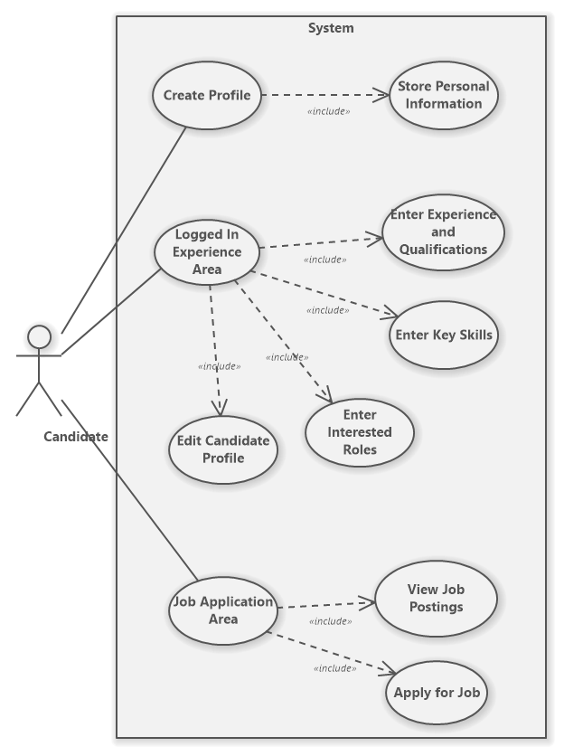

Figure 1: Candidate Use Case

Business Client:

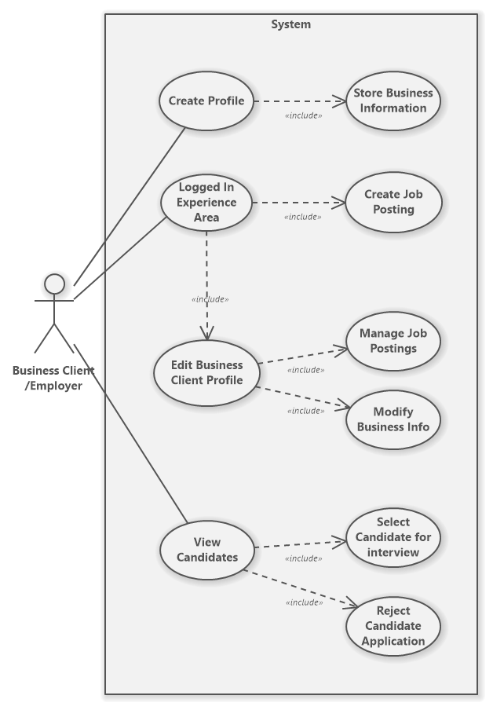

Figure 2: Business Client Use Case

Advisor:

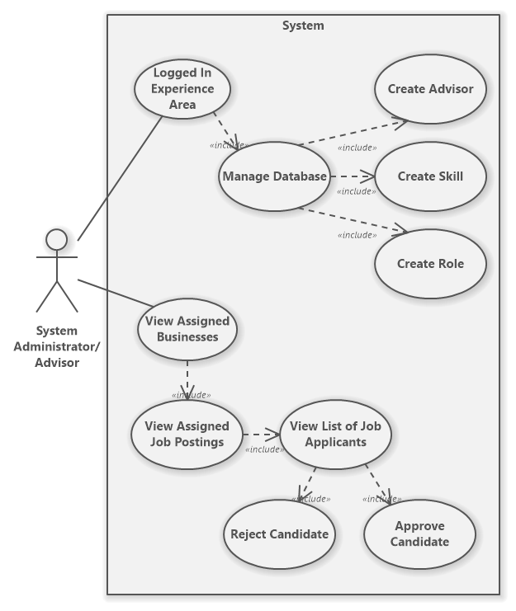

Figure 3: System Admin Use Case

## Use Case Descriptions and Scenarios

**CANDIDATE:**

Candidate Use Case 1: Create Profile

* Click on the Sign-Up button and the system will redirect the user to the registration page.
* Select Candidate and input the appropriate information.
* Click on Sign Up button within registration form.
* The system will validate the registration information. If valid, the system will display a success message and a Candidate account will be created. If invalid, the system will display the appropriate error message and no account will be created.

Candidate Use Case 2: Enter Experience and Qualifications

* Select Candidate and login to the application with a valid username and password.
* To add an education, click on the green icon beside Education. A popup form will appear.
  + Input the appropriate data into the popup form.
  + Click Add to add the education.
  + The system will validate the education information. If valid, the system will display a success message and the education will be added to the Candidate’s account. If invalid, the system will display the appropriate error message and no education will be added.
* To add work history, click on the green icon beside Work History. A popup form will appear.
  + Input the appropriate data into the popup form.
  + Click Add to add the work history.
  + The system will validate the work history information. If valid, the system will display a success message and the work history will be added to the Candidate’s account. If invalid, the system will display the appropriate error message and no work history will be added.

Candidate Use Case 3: Enter Skills

* Select Candidate and login to the application with a valid username and password.
* To add a skill, click on the green icon beside Skills. A popup form will appear.
* Input the appropriate data into the popup form.
* Click Add to add the skill.
* The system will validate the skill information. If valid, the system will display a success message and the skill will be added to the Candidate’s account. If invalid, the system will display the appropriate error message and no skill will be added.

Candidate Use Case 4: Enter Interested Roles

* Select Candidate and login to the application with a valid username and password.
* To add a role, click on the green icon beside Roles. A popup form will appear.
* Input the appropriate data into the popup form.
* Click Add to add the role.
* The system will validate the role information. If valid, the system will display a success message and the role will be added to the Candidate’s account. If invalid, the system will display the appropriate error message and no role will be added.

Candidate Use Case 5: Edit Candidate Profile

* Select Candidate and login to the application with a valid username and password.
* Click on the edit profile icon beside Info. The Candidate will be redirected to their edit page.
* To edit any of the Candidate’s personal information, select the Personal Information tab (selected by default) and input new data into the appropriate field(s)
* To edit any of the Candidate’s work history, select the Work History tab and input new data into the appropriate field(s)
* To edit any of the Candidate’s education, select the Education tab and input new data into the appropriate field(s)
* To edit any of the Candidate’s skills, select the Skills tab and input new data into the appropriate field(s)
* To edit any of the Candidate’s roles, select the Roles tab and input new data into the appropriate field(s)
* After editing any of the data in the Candidate’s profile, press Save Changes button, to save the changes. The system will validate the profile information. If valid, the system will display a success message and the Candidate’s profile will be updated. If invalid, the system will display the appropriate error message and the Candidate’s profile will not be updated.

Candidate Use Case 6: Job Application Area

* Select Candidate and login to the application with a valid username and password.
* Specify the search criteria.
  + Choose to search by either Title or Location.
  + Apply filters for the job type and salary range.
* Click on the magnifying glass icon to search.
* The system will check the database for any jobs matching the search criteria. If a match was found, the system will display “Found Match” and below an accordion menu will contain the job(s) information.
* To apply for a job posting, expand the accordion menu and press Apply Now. If the Candidate has not yet applied for this job posting, the system will display a success message and the Candidate will be added as an applicant to the job posting. Else if the candidate already has applied for the job, the system will display an error message and the Candidate will not be reinserted into the job posting.

**BUSINESS CLIENT:**

Client Use Case 1: Create Profile

* Click on the Sign Up button and the system will redirect the user to the registration page.
* Select Business Client and input the appropriate information.
* Click on Sign Up button within registration form.
* The system will validate the registration information. If valid, the system will display a success message and a Business Client account will be created. If invalid, the system will display the appropriate error message and no account will be created.

Client Use Case 2: Create Job Posting

* Select Business and login to the application with a valid username and password.
* To add a job posting, click on the green icon beside Postings. A popup form will appear.
* Input the appropriate data into the popup form.
* Click Add to add the job posting.
* The system will validate the job posting information. If valid, the system will display a success message and the job posting will be created. If invalid, the system will display the appropriate error message and no job posting will be created.

Client Use Case 3: Edit Profile

* Select Business and login to the application with a valid username and password.
* Click on the edit profile icon beside Info. The Business Client will be redirected to their edit page.
* To edit any of the Business Client’s business information, select the Business Information tab (selected by default) and input new data into the appropriate field(s)
* To edit any of the Business Client’s job postings, select the Job Postings tab and input new data into the appropriate field(s)
* After editing any of the data in the Business Client’s profile, press Save Changes button, to save the changes. The system will validate the profile information. If valid, the system will display a success message and the Business Client’s profile will be updated. If invalid, the system will display the appropriate error message and the Business Client’s profile will not be updated.

Client Use Case 3: View Candidates

* Select Business and login to the application with a valid username and password.
* If the logged in Business Client does not have any job postings, they must first create one.
* Under the Postings section, click on View Candidates for a specific job posting. The system will redirect the user to that specific job posting.
* Any candidates that have been approved by the Advisor will appear here. By expanding the accordion menu, the Business Client can choose to either reject or select the Candidate for interview.
* To select Candidate for interview, press select for interview.
  + The system will send an email to the Candidate letting them know they’ve been selected for interview.
* To reject the Candidate, press reject.

**SYSTEM ADMIN/ADVISOR:**

Advisor Use Case 1: Manage Database

* Select Advisor and login to the application with a valid username and password.
* To create a new advisor select Add new advisor. A popup form will appear.
  + Input the appropriate registration information for the advisor into the form.
  + Click Add to create the new advisor account.
  + The system will validate the registration information. If valid, the system will display a success message and the new advisor account will be created. If invalid, the system will display the appropriate error message and the advisor account will not be created.
* To create a new skill select Add new skill.
  + Input the skill description into the form.
  + Click Add to add the new skill.
  + The system will validate the skill description and check if the skill currently exists. If the skill does not exist, the system will display a success message and the new skill will be persisted in the database. If the skill does exist, the system will display an error message saying, “skill already exists.”
* To create a new role select Add new role.
  + Input the role description into the form.
  + Click Add to add the new role.
  + The system will validate the role description and check if the role currently exists. If the role does not exist, the system will display a success message and the new role will be persisted in the database. If the role does exist, the system will display an error message saying, “role already exists.”

Advisor Use Case 2: Manage Assigned Businesses

* Select Advisor and login to the application with a valid username and password.
* The system automatically assigns job postings and their associated business client with the advisors in our application.
* If this advisor has an assigned business, it will be displayed under the Assigned Businesses section.
* To view business information, expand the accordion menu for the specific business client.
* To view a list of job postings for a specific business, press List job postings. The system will redirect the user to the job postings page for the advisor.
* Job postings assigned to the advisor will be listed under the Job Posts section.
* To see job posting information, expand the accordion menu for that specific job posting.
* To view job applicants, click on Applicants button. The system will redirect the user to the candidate view page for the advisor.
* Candidates that have applied to the specified job posting will be listed under the Candidates section.
* To view Candidate information, expand the accordion menu for that specific Candidate.
* To reject a Candidate, Press Reject. The system will display a success message saying, “Candidate Rejected”.
* To approve a Candidate, Press Approve. The system will display a success message saying, “Candidate Approved”

## 

## Non-Functional Requirements

The System administrators/advisors are required to vet all information for legitimacy within our system and ensure no scams are occurring. Additionally, the System administrators/advisors are required to oversee any fees that take place on our system.

## System Interface Requirements

###### The project is required to be a web application so that anybody can access it through the internet.

## Usability Requirements

Our client never explicitly stated usability requirements. However, any web application requires UI elements that are common across different websites so that the application is more user friendly in terms of the user’s preexisting mental model.

Problem Domain Class Diagram

* *should model the problem domain only*
  + *i.e. problem domain classes only: assume they can communicate directly with actors and are persistent*

## System Design

**Layered Architecture**

Data Access

Filters

Problem Domain

Services

Servlets

Strategies

Util

**Hardware Architecture**

* *textual description; deployment diagram; communication mechanisms*

**Hardware Platform**

* *required hardware specs to develop and maintain*
* *required hardware specs for production system*

*Processor: Intel Core i5-8350U CPU at 1.70GHz*

*RAM: 16 GB*

*System Type: 64-bit Operating System*

**Software Platform**

* *required software specs to develop and maintain*
* *required software specs for production system*
* The software platform that was used to develop this project was Apache NetBeans. MySQL was used for the databases. For the deployment we used Heroku and JawsDB.

**Interaction Model**

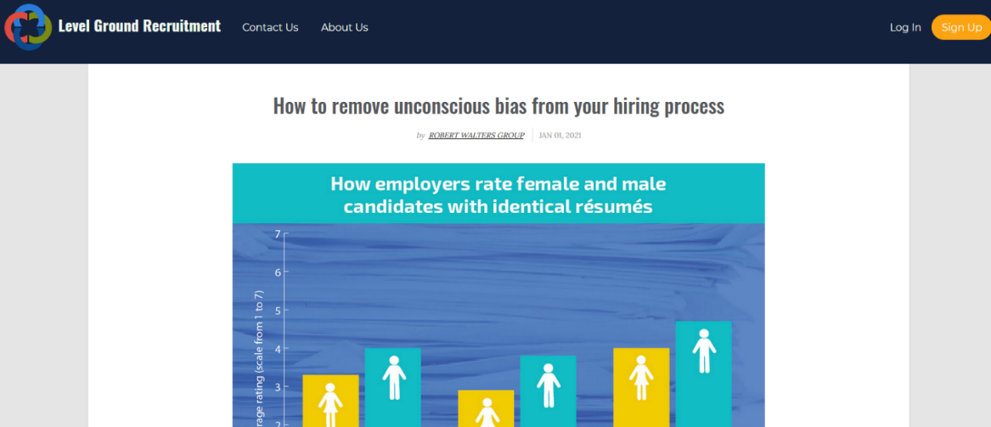

Figure 4: Landing Page

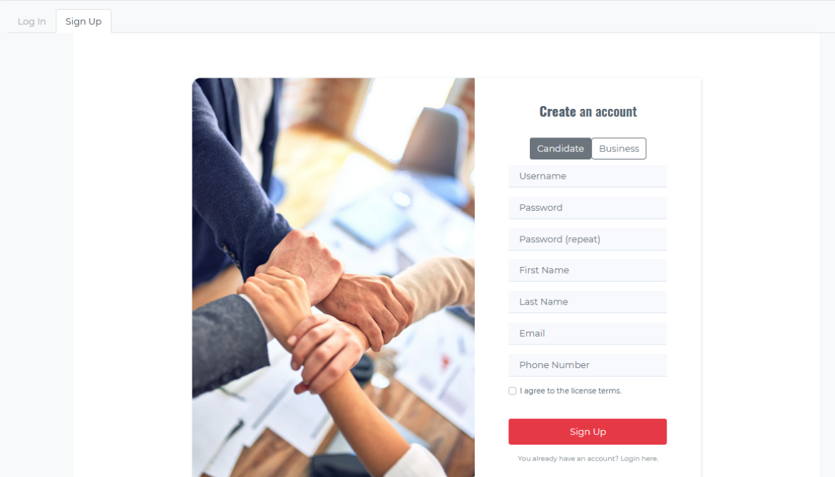

Figure 5: Sign-up/Log-in Page

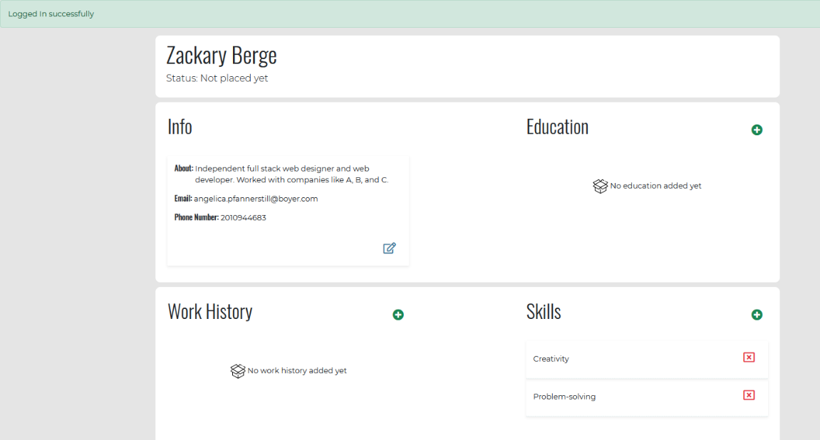

Figure 6: Candidate Profile Page

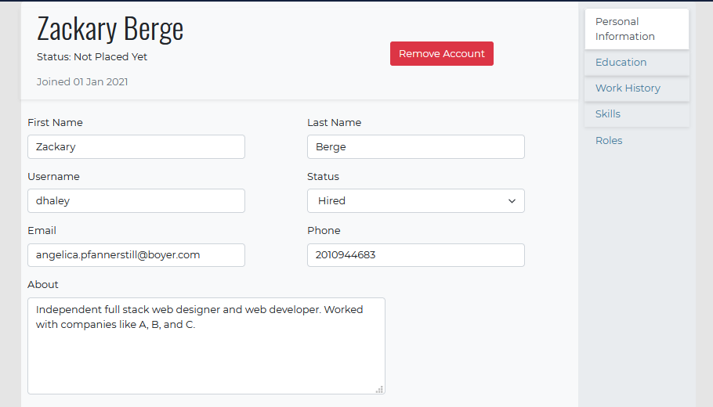

Figure 7: Candidate Edit Profile Page

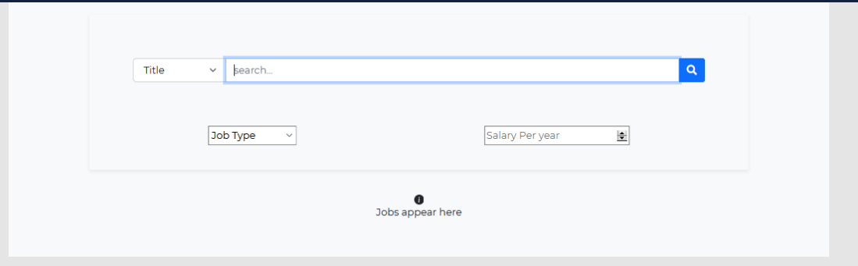

Figure 8: Candidate Job Posting Search Page

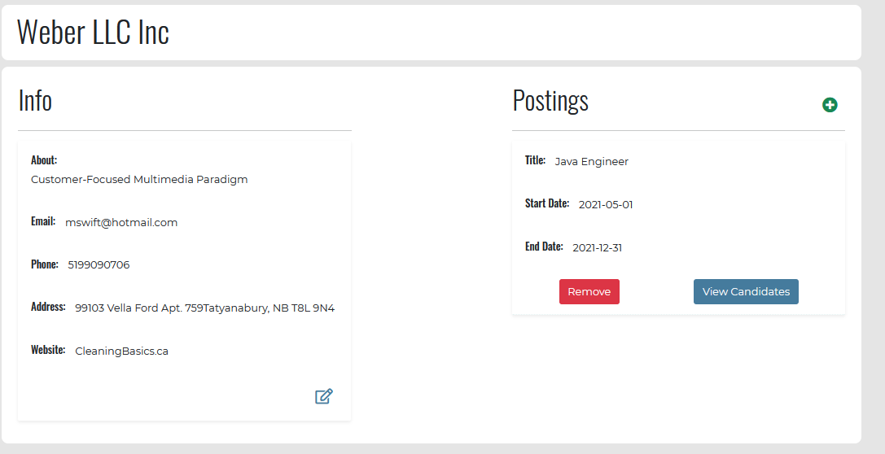

Figure 9: Business Client Profile Page

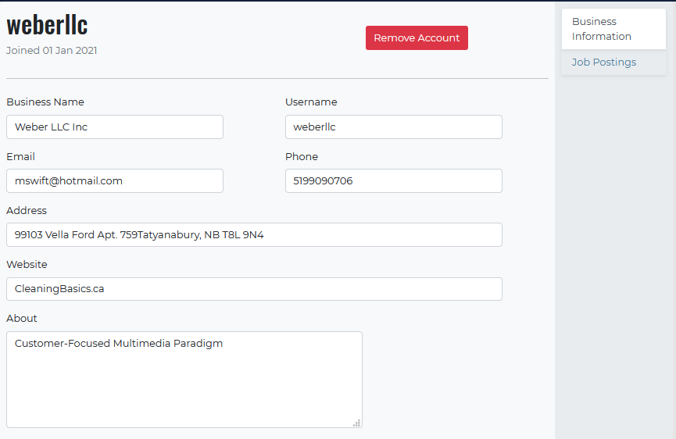

Figure 10: Business Client Edit Profile Page

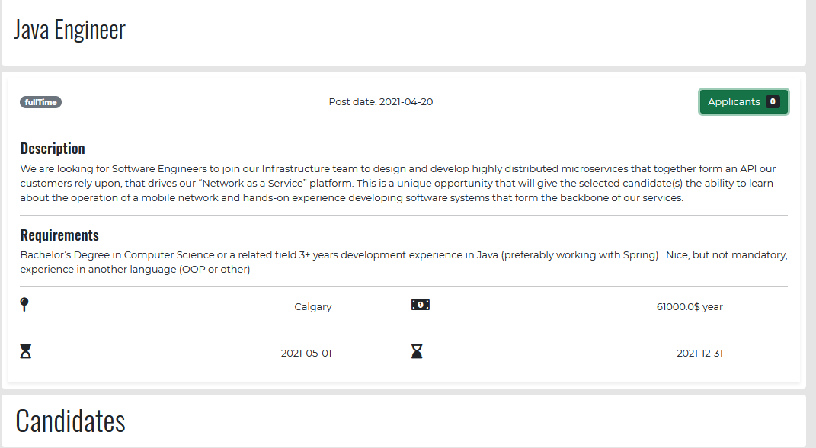

Figure 11: Business Client Job Posting Page

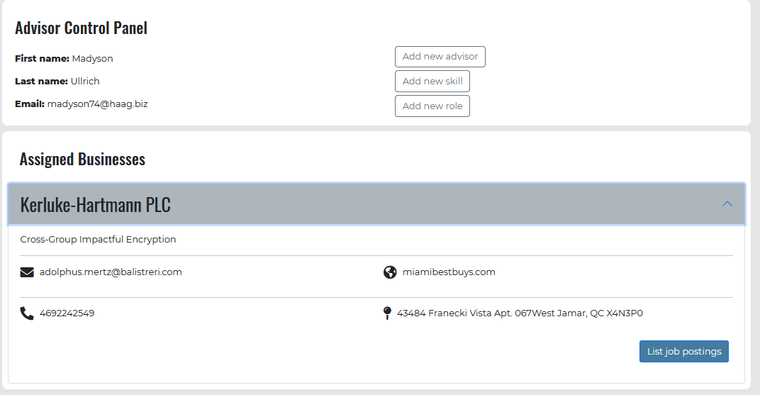

Figure 12: System Admin Profile Page

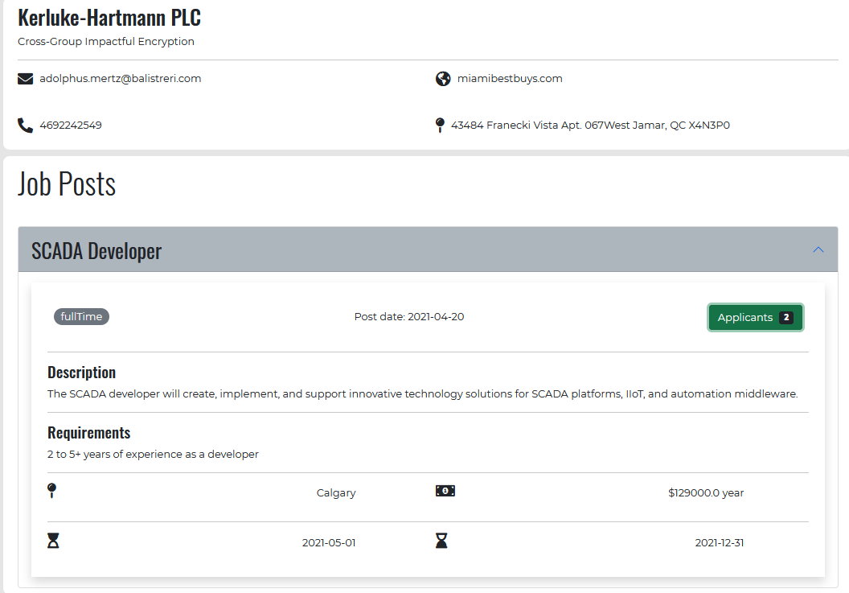

Figure 13: System Admin Business View Page

**Persistence Model**

* *textual description of mechanism*
* *Conceptual Schema ERD(as per Systems Analysis and Design course)*

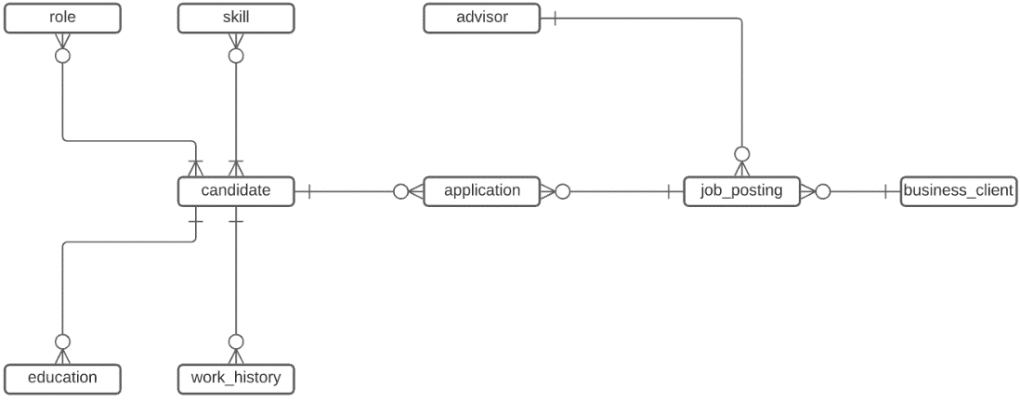

Figure 14: Conceptual ERD

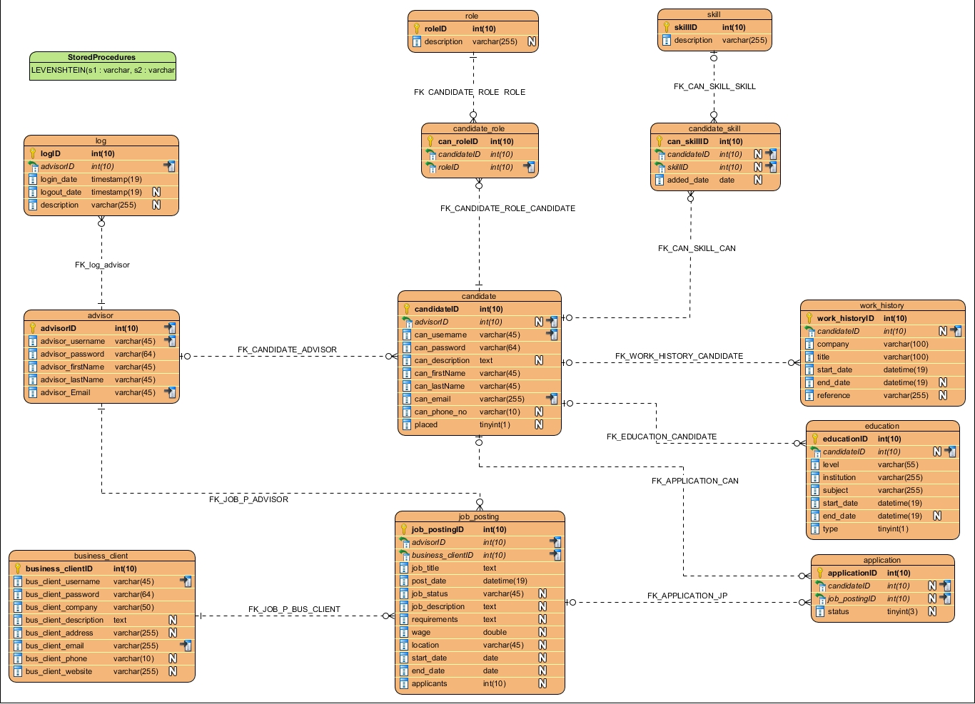

Figure 15: Physical ERD

* *Internal Schema ERD (3NF physical model as per Database courses)* ***or*** *file structures*
* *expected data size (data size for each persistent class * expected max number of stored objects of each class)*

**Class Diagram**

Data access Package

Problem Domain

Services Package

Servlets Package

Strategies Package

Utility Package

Validation Package

* *one class diagram per package (including system administration classes)*
* *well-defined, patterns noted*

**Interaction Sequence Diagrams**

Create profile

Create Job Posting

**State chart Diagrams**

* *one for each complex time dependent behaviour*
* *at least one to model the overall flow through an HCI at the screen level*

**Activity Diagrams**

* *one for each object that exhibits complex processing (there may be 0 or more)*

**Data Dictionary of Problem Domain and Application Domain**

*including* **Operation Specifications -> JAVADOC ???**

**Testing**

**Test Plans**

* *including forms, narratives, test data, test scripts and testing tools and utilities that were used for each test –****include*** *completed test forms from development.*

**System Deployment**

**Data Conversion**

**Changeover Strategy**

**System Administration and Maintenance**

* *Class Diagrams, Interaction Diagrams, Attributes and Operations and/or* ***manual*** *procedures required for:*

**Security**

**Operation**

**Backup and Restore**

**Data Archival**

**System Maintenance**

* *sections of the system identified as likely to require changes*
* *recommended techniques to maintain those sections*

## Deficiency List

**Requirements Not Met**

Not Applicable. All the requirements are met.

**Non-Functioning Components**

## The filters are not working as they should on the Job Postings search page.

## Appendix

**Program Listings**

* *directions to find* ***soft*** *copies of* ***all*** *code, fully documented, plus full generated javadoc files*

## Glossary

###### definitions of **technical** terms used in this document

|  |  |
| --- | --- |
| Term | Description |
| Backup and Restore |  |
| Business Client | A business that is looking to employ candidates. |
| Candidate | A person seeking to be employed. |
| Class Diagram | A diagram that describes the structure of the system’s classes, their attributes, operations and relationship among objects. |
| Client | A person who initiates the project and whom the project is being completed for. |
| Changeover Strategy |  |
| Data Archival |  |
| Data Dictionary | A set of information describing the content, format and structure, and information about data models and elements. |
| Data Conversion |  |
| Deficiency List | A list of work that needs repair or incomplete work in a project. |
| End-User | A person who uses the final product. Our system is designed for these users. |
| Hardware Architecture |  |
| Hardware Platform |  |
| Layered Architecture |  |
| Maintainability requirements | Requirements to keep the system maintained over time. |
| Non-Functional Requirements | The requirements that are performed outside of the project scope. |
| Persistence Model |  |
| Problem Domain |  |
| Project Scope | List of goals, deliverables, tasks, costs and deadlines. |
| Software Platform |  |
| Statechart Diagram |  |
| System Administrator/Advisor | An admin that facilitates the hiring process. |
| System Interface Requirements | Requirements, if necessary, of a system to communicate with other computer systems. |
| System Maintenance | Sections of a system that will likely need reworking in the future. |
| Test Plan | A detailed step by step plan to ensure the component(s) is working as expected. |
| Usability Requirements | Requirements of a system to match system to users, and tasks users will perform. |
| Use Case Description | A detailed, step by step scenario of each action contained in a use case. |
| Use Case Diagram | A diagram that provides actions for a specific user of the system. |

## Index

###### more than a reformatted table of contents

|  |  |
| --- | --- |
| Topic | Pages |
|  |  |
|  |  |
|  |  |